Stages of compilation:
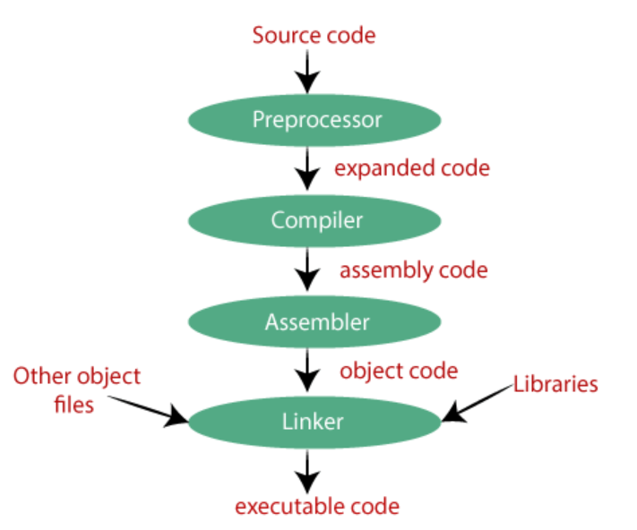
Preprocessing: source code to expanded source code
It performs tasks such as including header files, expanding macros, and removing comments.
Includes files: If your code needs some other files (like libraries), the preprocessor adds them. For example, when you use #include <stdio.h>, it brings in the code from that file.
Expands macros: If you've used shortcuts like #define PI 3.14, it replaces PI with 3.14 everywhere in your code.
Compilation: expanded source code to assembly code
example assembly code:
mov eax, [ebp+8]
add eax, [ebp+12]
mov [ebp-4], eax
mov eax, [ebp-4]

Assembler: assembly code to object code

Linker:
These library functions are pre-compiled, and the object code of these library files is stored with '.lib' (or '.a') extension. The main working of the linker is to combine the object code of library files with the object code of our program.
The output of the linker is the executable file (.exe)
Header files (stdio.h) typically contain declarations (like function prototypes) and doesn’t include the actual implementation or machine code for these functions. The actual machine code (or object code) for functions like printf is stored in compiled library files, not in header files.
Loader:
Loads the executable file from secondary memory to main memory to execute

Static linking:
Static linking combines all the parts of a program, including libraries, into one single executable file.
Benefit: There is no runtime dependency on any external libraries.
Dynamic linking:
Instead of including all library code in the executable, the linker adds "stub" for the libraries. During runtime, when the program runs, these stub check if the library is already in memory(main memory). If not, the program loads the library as needed.
Benefit: This saves memory

Static loading:
Loaded Executable file contains all the necessary libraries.
Dynamic loading:
stub loads the required library files if they are not present in main memory.

Runtime or Program Execution:
Now during execution of executable file in CPU, it uses main memory to store variables present in the code.
Code = memory used to store the executable code.
Data = to store static/global variables
Stack = to store local variable
Heap = During dynamic memory allocation, memory is borrowed from the heap.
All code, data, stack, heap belongs to main memory

Complier and interpreter?
In compiler, firstly source code is entirely converted to executable file and this executable file was loaded inside main memory and then executed.
Example: C, C++
In interpreter, each line is first converted into machine code and then executed immediately before moving on to the next line
Example: Python, Ruby
Compiler runs faster than interpreter (in codeforces, python gives more TLEs)
In compilation entire executable file was made to run at a time in CPU....
But in interpretation, each line has to run individually each time in CPU...
Dispatching line by line rather than dispatching whole executable file at a time leads to more time in interpretation
Compilation requires more memory than interpretation
Because executable file requires some space
In Compiler all errors are listed before execution
In interpreter, code stops running at first error

Is Java a compiler or interpreter?
Java uses both compiler and interpreter - javac and JVM
1. Java Compiler (javac):
The source code (written in .java files) is compiled into bytecode
This bytecode is a platform-independent code that can be run on any machine that has a Java Virtual Machine (JVM).
Bytecode makes Java platform-independent because it can run on any operating system (Windows, Mac, Linux) and hardware architectures that has a JVM, without needing to recompile the code for each platform.
(Write Once, Run Anywhere (WORA) principle)
2. Java Interpreter (JVM):
The JVM interprets the bytecode line by line. This means it reads each line (or instruction) of bytecode, converts it into machine code, and executes it immediately before moving on to the next line.
To improve performance, the JVM also uses a technique called Just-In-Time (JIT) compilation
When the JVM notices that certain parts of the bytecode (like loops or frequently called methods) are being used repeatedly, it compiles those parts into machine code and stored inside Code Cache in main memory
When the JVM encounters a part of the code that has been JIT-compiled, it directly executes the precompiled machine code.

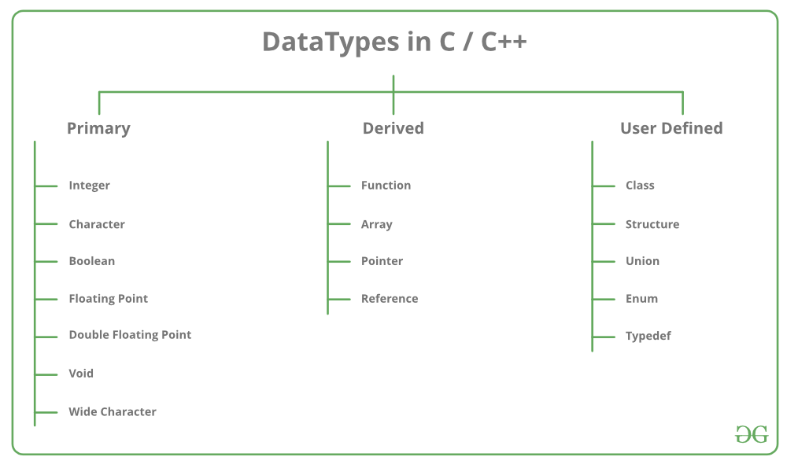

Size of empty class = 1 (to identify it inside memory)
size of bool = 1
Char = 1
short = 2
int = 4
long = 4
long long = 8
float = 4
double = 8
long double = 16

sizeof(void) → 1 in gcc compilers, not valid in other compilers.
The void type represents "no type" or "absence of a type" and is used for functions that do not return a value
sizeof(void*):
A void* is a pointer to an unknown data type, often used for generic pointers
On a 32-bit system, sizeof(void*) is typically 4 bytes.
On a 64-bit system, sizeof(void*) is typically 8 bytes.

What will happen when we keep some return 10 or return 100 in place of return 0 inside int main( )?
The return value of int main( ) is nothing but exit code of the program
This exit code is sent as signal to the OS indicating whether the program executed successfully or not
return 0; means the program ended successfully, with no errors.
return x; (where x is some non 0) means the program ended with an error
This may affect the output of the other programs which are dependent on the current program

Can main( ) function be overloaded?
The first thing to remember is that main is not a reserved word in C++, C, C#, java
So the answer to the above question is yes.
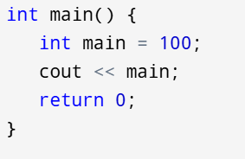
Output: 100
But the thing is we can overload it only inside a class. Not directly
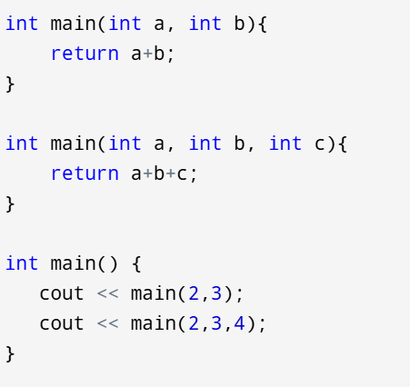
Compilation error

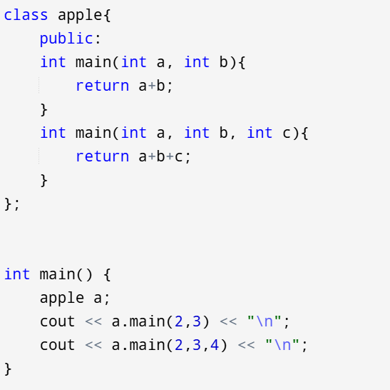
5
9

namespace:
When we write some variables or functions inside a namespace, then scope of those variables and functions will be defined as the corresponding namespace.
Namespaces are used to avoid name collisions.
we can differentiate between 2 identical variables/functions based on their namespaces
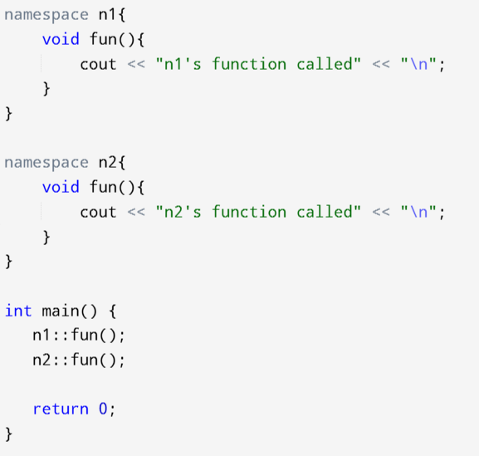
n1's function called
n2's function called
Note that there is no semicolon at the end of definition

using namespace n1;
it means you are importing all the variables and functions inside n1 into current scope.
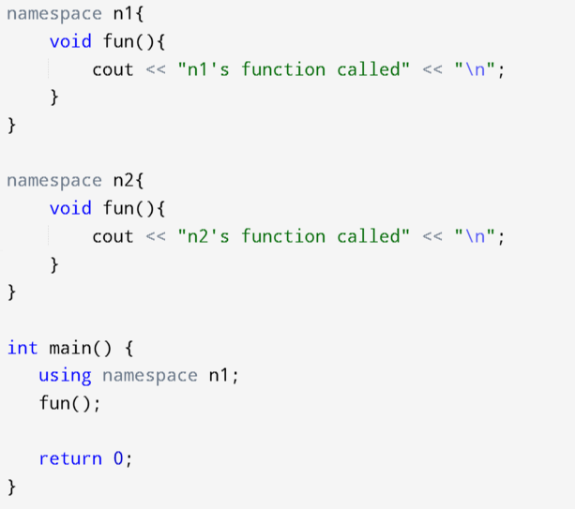
n1's function called
Then why using namespace std; is considered to be a bad practice?
Ans: It pollutes the global scope.
std namespace contains a huge number of functions like cout, vector, string
When we write using namespace std, we are importing all the functions inside std into current global scope.
So it may conflict with
Names from your own code.
Names from other libraries.

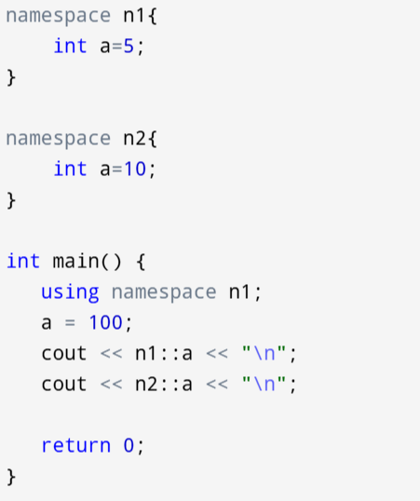

char *buff = "NVIDIA";
buff[0] = 'n';
Above is a runtime error.
In this code, buff is a pointer to a string literal "NVIDIA".
String literals in C are typically stored in a read-only section of memory, which means you cannot modify their contents.
When you try to change buff[0] to 'n', you are attempting to modify a read-only memory location, which leads to segmentation fault.
char buff[] = "NVIDIA";
buff[0] = 'n';
This works fine

Type casting:
1.Implicit type casting: done by compiler without any indication by the user
int x = 10;
char y = 'a';
x = x + y;
It is possible for implicit conversions to lose information:
->signs can be lost (when signed is implicitly converted to unsigned)
->overflow can occur (when long long is implicitly converted to float).

2.Explicit type casting:
a)C style typecasting:
double x = 1.2;
int sum = (int)x + 1;
b)using cast operator:
1.static cast: most preferable cast
static means done during compile time
a) c style cast is hard to find in code, identifying casting in the code will be easier using static.
so code debugging will be easy
float f = 3.5;
int a = (int)f;
int b = static_cast<int>(f);

b)static_cast is more restrictive than C style

int main()
{
char c = 'a';
int* q = (int*)&c; // Pass at compile time, may fail at run time
int* p = static_cast<int*>(&c); //compilation error
}
Its dangerous to type cast char pointer to integer pointer
When we write *p = 5 afterwards there will be unexpected behaviour because for character 1 byte is assigned but we are trying to modify 4 bytes
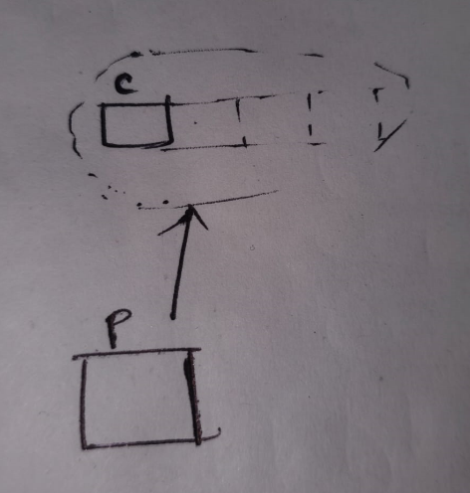
class Base{
};
class Derived : private Base{
};

int main()
{
Derived D;
Base* bp1 = (Base*)(&D); //C style casting allowed
Base* bp2 = static_cast<Base*>(&D); //compilation error : 'Base' is an inaccessible base of 'Derived'
}
During private inheritance, static_cast will give compilation error during upcasting. So its providing safety

c)casting to void* and casting from void* (void * is generic pointer)
int main()
{
int a = 5;
int *p = &a;

void *q = static_cast<void*>(p);
int *r = static_cast<int*>(q);

cout << *r ; //5
}

d)used during conversion operator(not understood)

2.dynamic casting:
is mainly used for safe downcasting at run time
dynamic cast has runtime overhead, because at runtime it has to check objects. (using RTTI)
So try to prefer static cast if you are enough confident that your code has safe downcasting.
upcasting: deriver reference to base reference or deriver pointer to base pointer
downcasting: base reference to derived reference or base pointer to derived pointer
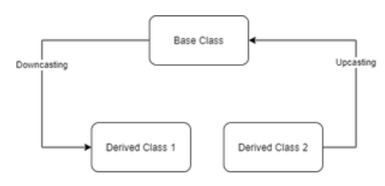

a) dynamic_cast works only polymorphic base class(containing virtual functions) because it uses this information to decide safe downcasting.
class Base{
void print(){
cout << "Base class" << "\n";
}
};
class Derived1 : public Base{
void print(){
cout << "Derived1 class" << "\n";
}
};
class Derived2 : public Base{
void print(){
cout << "Derived2 class" << "\n";
}
};

int main()
{
Derived1 D1;
Base* bp = dynamic_cast<Base*>(&D1); //upcasting
Derived1* d1p = dynamic_cast<Derived1*>(bp); //downcasting
}
Output: (source type is not polymorphic)//compilation error

b)If casting is not successful;
If newtype is pointer type then returns null pointer (*****)
if newtype is reference type then throws an exception of bad cast

class Base{
virtual void print(){
cout << "Base class" << "\n";
}
};
class Derived1 : public Base{
void print(){
cout << "Derived1 class" << "\n";
}
};
class Derived2 : public Base{
void print(){
cout << "Derived2 class" << "\n";
}
};

int main()
{
Derived1 D1;
Base* bp = dynamic_cast<Base*>(&D1); //upcasting
Derived1* d1p = dynamic_cast<Derived1*>(bp); //downcasting
if(d1p==NULL)
cout << "NULL" << "\n";
else
cout << "NOT NULL" << "\n";
}

Output : NOT NULL

*******most imp example
class Base{
virtual void print(){
cout << "Base class" << "\n";
}
};
class Derived1 : public Base{
void print(){
cout << "Derived1 class" << "\n";
}
};
class Derived2 : public Base{
void print(){
cout << "Derived2 class" << "\n";
}
};

int main()
{
Derived1 D1;
Base* bp = dynamic_cast<Base*>(&D1); //upcasting
Derived2* d2p = dynamic_cast<Derived2*>(bp); //downcasting
if(d2p==NULL)
cout << "NULL" << "\n";
else
cout << "NOT NULL" << "\n";
}

Output : NULL
cast fails and new_type is a reference type then bad cast exception
int main()
{
Derived1 D1;
try {
Derived2& r1 = dynamic_cast<Derived2&>(D1);
}
catch (std::exception& e) {
cout << e.what() << endl;
}
}
Output: std::bad cast

3. reinterpret cast in C++:
It is very dangerous because it can typecast any pointer to any other pointer used when we want to work with bits.
struct mystruct {
int x;
int y;
char c;
bool b;
};

int main()
{
mystruct s;

s.x = 5;
s.y = 10;
s.c = 'a';
s.b = true;

int* p = reinterpret_cast<int*>(&s);
cout << sizeof(s) << endl;
cout << *p << endl;
p++;
cout << *p << endl;
p++;
char* ch = reinterpret_cast<char*>(p);
cout << *ch << endl;
ch++;
bool* n = reinterpret_cast<bool*>(ch);
cout << *n << endl;
}
Output:
12
5
10
a
1

4. const cast: (pending)

Dynamic memory allocation:
The most important use is the flexibility provided to programmers. We are free to allocate and deallocate memory whenever we need it and whenever we don’t need it anymore.
Firstly in C: defined in <stdlib.h> header file
malloc, calloc, realloc, free

malloc( ):
used to dynamically allocate a single large block of memory from the heap.
int* ptr = (int*) malloc(100 * sizeof(int));
return type of malloc is void pointer, as void pointer is a generic pointer we have to typecast it into desired datatype
returns a NULL pointer if there is no space in heap to allocate
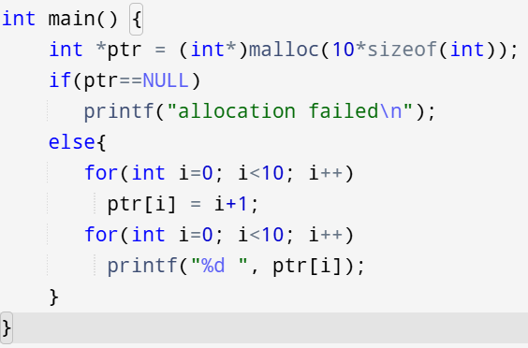
Output: 1 2 3 4 5 6 7 8 9 10

calloc( ): contiguous allocation (everything same as malloc() except default values)used to dynamically allocate contiguous blocks of memory from the heap (indirectly malloc( ) also does the same)
int* ptr = (int*) calloc(100, sizeof(int));
same as malloc() return type is a void pointer, if no space in heap then a NULL pointer
In malloc() default values are garbage values but here default values are zeros.
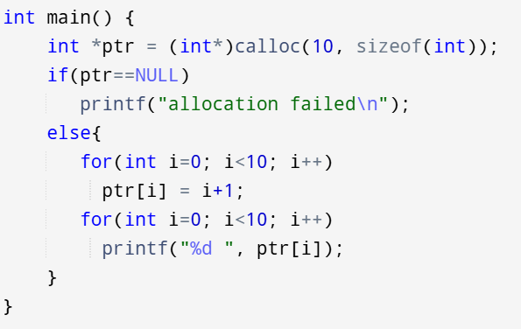
Output: 1 2 3 4 5 6 7 8 9 10

realloc():
generally used after malloc( ) or calloc( )
if the memory previously allocated with the help of malloc or calloc is insufficient, realloc can be used to dynamically re-allocate memory.
it maintains the old values as it is, and new blocks are initialized with garbage values
int *ptr = (int*)malloc(5*sizeof(int));
ptr = realloc(ptr, 10*sizeof(int)); //10 is the new size
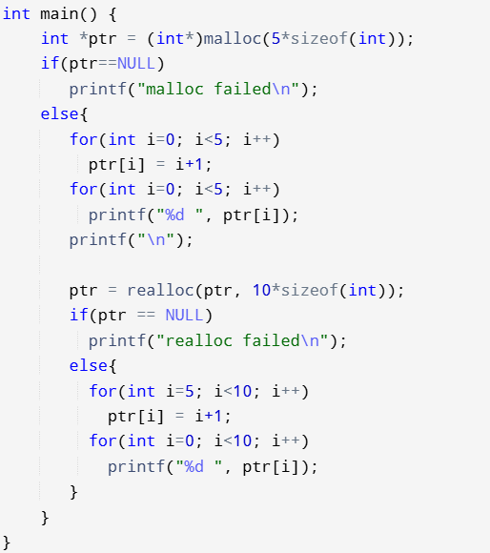
Output:
1 2 3 4 5
1 2 3 4 5 6 7 8 9 10
free( ) :
used to deallocate the memory borrowed from heap
Its users responsibility to deallocate the memory borrowed from heap
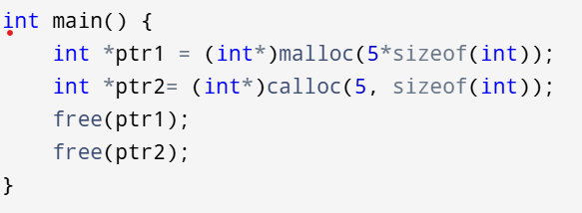

in C++, new and delete:
malloc( ), calloc( ), realloc( ), free( ) are library functions, but new and delete are keywords
new:
similar to malloc and calloc, it is also used to dynamically allocate memory from the heap.
normally it will return the base address of heap memory
If there is no enough heap memory, then it will give an exception of std::bad_alloc
If we mention nothrow then it returns a NULL pointer when no enough heap memory
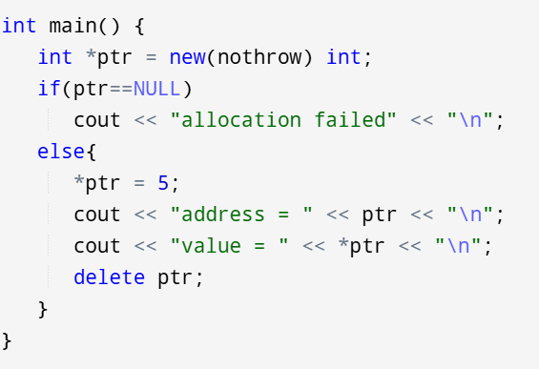
Output :
address = 0x1cf3eb0
value = 5

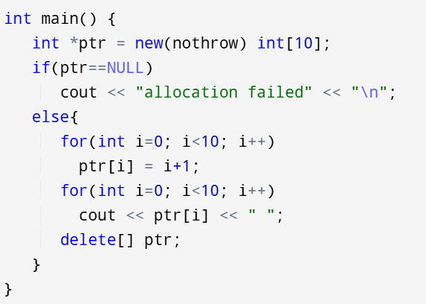
Output : 1 2 3 4 5 6 7 8 9 10

delete:
used to deallocate memory, already used above

difference between malloc( ) and new:
1.malloc( ) = library function, new = keyword
2.In malloc( ) constructor wont be called and in new constructor will be called
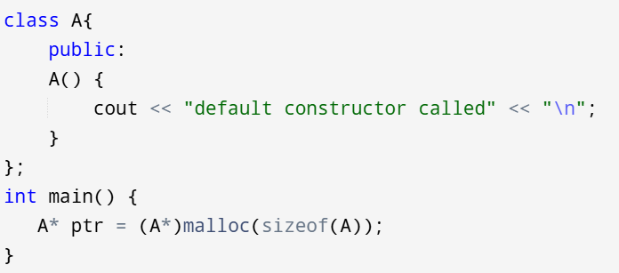
Output: blank
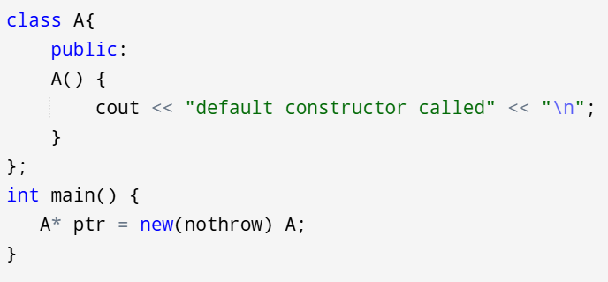
Output: default constructor called
difference between free( ) and delete:
free( ) wont calls destructor and delete calls destructor

Memory leaks:
When memory is borrowed from the heap, its programmers responsibility to manually deallocate the memory using delete or free( )
If programmer forgot to free this memory, it will occupy the space upto program termination and will be unavailable to other processes. This is called memory leak.
How to avoid Memory Leak?
1.Heap memory must be deallocated using delete or free( )
2. Use std::string instead of char *. The std::string class handles all memory management internally, and it’s fast and well-optimized.
3. Instead of managing memory manually, try to use smart pointers where applicable.
4. Anything that requires dynamic memory should be buried inside an RAII object. This RAII object releases the memory when it goes out of the scope using destructor.
(RAII = Resource Acquisition Is Initialization)

Smart Pointers:
The main issue that occurs with the normal pointers is memory leaks. It is user’s responsibility to deallocate the heap memory. Otherwise it leads to memory leak.
So Smart pointers were introduced.
It is a wrapper class which wraps over current object.
Inside the wrapper class, we overload * and -> operators to access the data of the current object.
We also define destructor inside the wrapper class so that object will be automatically deleted without user intervention because smart pointer belongs to stack memory only.
1.unique_ptr: (watch implementation from scratch its not so difficult)
unique_ptr indicates exclusive ownership
i.e at an instant resource will be pointed by a single smart pointer. It cannot be shared between multiple smart pointers.

ptr1 is more preferable than ptr2 because there is a chance that we may forget to write the line delete ptr2
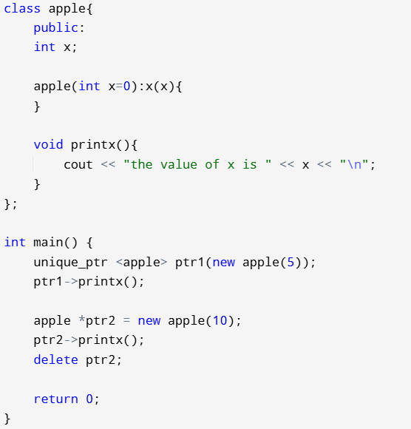

As unique_ptr follows exclusive ownership ie we cannot use copy constructor or copy assignment operator.
Below is a compilation error.
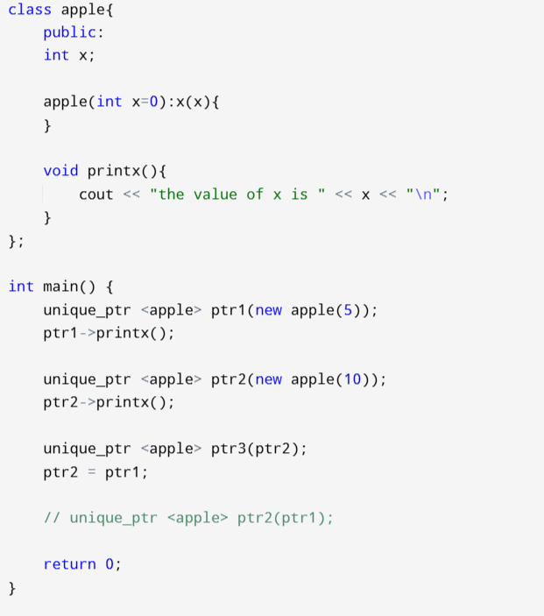

We can use move constructor and move assignment operator.
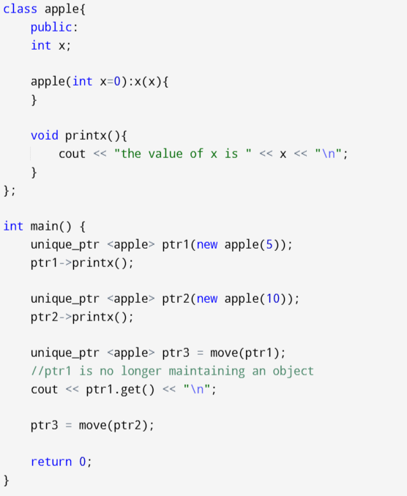
the value of x is 5
the value of x is 10
0

get() = returns the value of ptr1
reset() = deallocates older resource and resets with a new resource
if nothing sent as parameter then ptr points to NULL
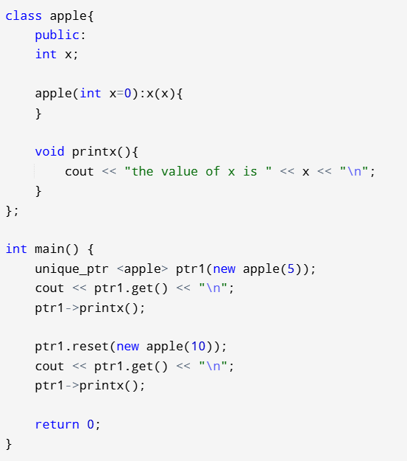
0x7aceb0
the value of x is 5
0x7ad2e0
the value of x is 10

Implementing unique_ptr:

class apple{
public:
int x;

apple(int x=0):x(x){
}

void printx(){
cout << "the value of x is " << x << "\n";
}
};

template <typename T>
class uniqueptr{
private:
T *res;

public:
uniqueptr(T *t) : res(t){
}

T* operator->(){
return res;
}

~uniqueptr(){
If(res){
delete res;
res = NULL;
}
}

uniqueptr(const uniqueptr &t) = delete;
uniqueptr& operator=(const uniqueptr &t) = delete;

uniqueptr(uniqueptr &&t){
res = t.res;
t.res = NULL;
}

uniqueptr& operator=(uniqueptr &&t){
if(this!=&t){
if(res)
delete res;
res = t.res;
t.res = NULL;
}
return *this;
}
};

int main() {
uniqueptr<apple> ptr1(new apple(5)); //parameterised ctor
uniqueptr<apple> ptr2(new apple(10)); //parameterised ctor

ptr1->printx(); //operator overloading

// uniqueptr<apple> ptr3 = ptr1; compilation error
// ptr2 = ptr1; //compilation error

uniqueptr<apple> ptr3 = move(ptr1); //move constructor
ptr3 = move(ptr2); //move assignment operator

return 0;
}

shared_ptr :
As the word says a resource can be shared between multiple pointers
A shared pointer points to (current object) and (control block which contains reference count)
Current object and control block are shared among multiple pointers
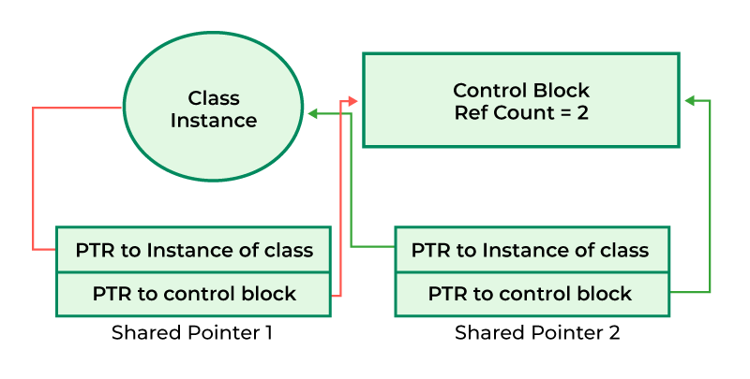

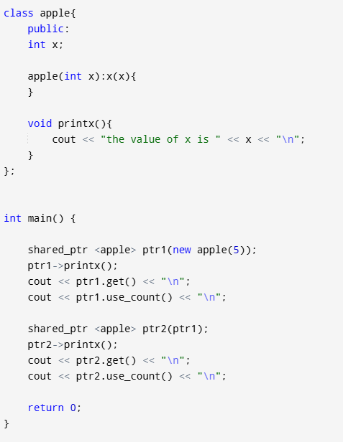
the value of x is 5
0x64ceb0
1
the value of x is 5
0x64ceb0
2

Reference count wont get incremented if we use reference type shared pointers
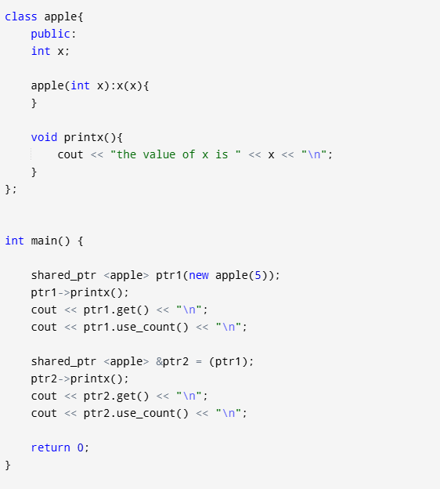
the value of x is 5
0x1d29eb0
1
the value of x is 5
0x1d29eb0
1

There are three ways shared_ptr will destroy managed object.
a) If the last shared_ptr goes out of scope.
b) If you initialise shared_ptr with some other shared_ptr.
c) If you reset shared_ptr.

weak_ptr:
unique_ptr has exclusive ownership and shared_ptr has multiple ownership
But weak_ptr has no ownership on the resource, its like a reference to the shared_ptr
expired() = check whether weak_ptr points to a resource or not
lock() = returns a shared_ptr which points to that resource.
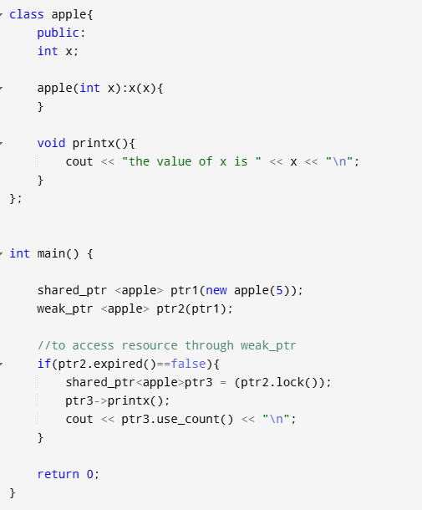
the value of x is 5
2

Why weak_ptr is needed?
In cyclic dependency there will be memory leak.
Lets say object A consisting of shared_ptr pointing to B
Lets say object B consisting of shared_ptr pointing to A
Then reference count of both pointers will never be 0 and resources A and B cannot be destroyed
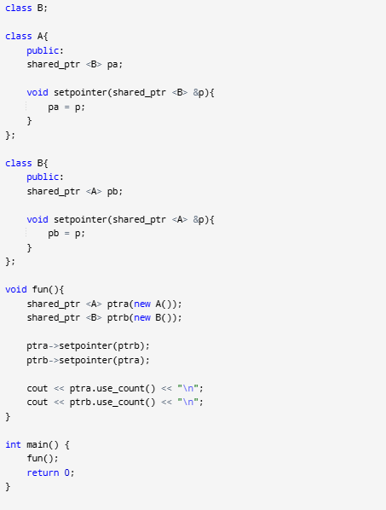
2
2

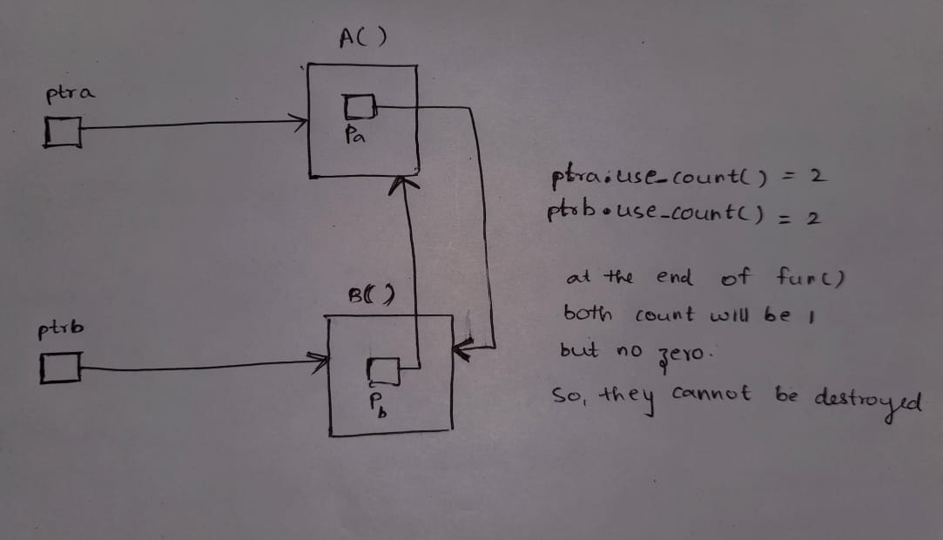

Solution : use weak_ptr
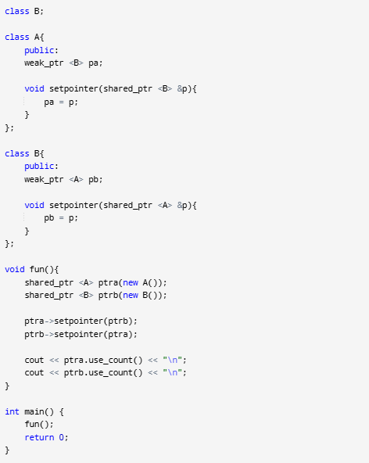
1
1

Pointer to an array or array pointer:
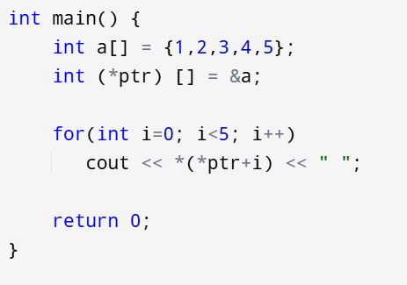
1 2 3 4 5

Array of pointers:
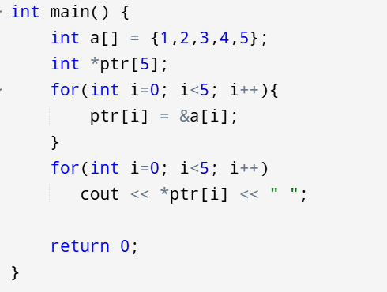
1 2 3 4 5

Function pointer or Pointer to a function:
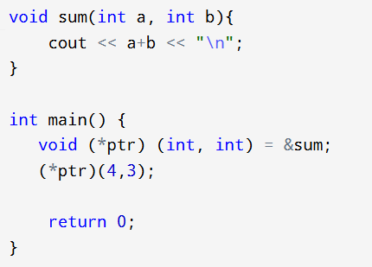
Output: 7

Unlike normal pointers, a function pointer points to code, not data.
Typically a function pointer stores the start of executable code.

array of function pointers:
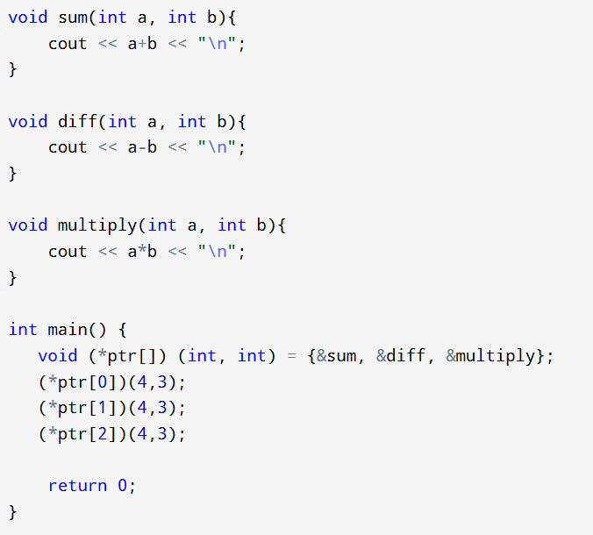
7
1
12

Dangling pointers = pointing to a non existing memory location.
Wild pointers = uninitialized pointers (points to arbitrary or some random memory location)
void pointers = generic pointers
NULL pointers = no pointing (value of ptr is 0)

Dangling pointers:
A pointer pointing to some non existing memory location.
They leads to unexpected behaviours
1)When a memory pointed by a pointer is deallocated the pointer becomes a dangling pointer. So we have make sure that it points to NULL after deallocation.
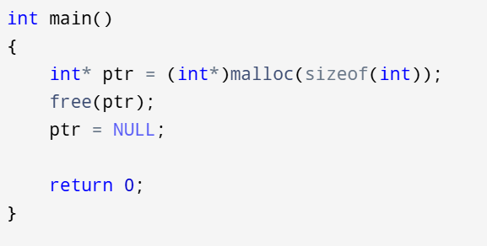
2)When variable goes out of scope:
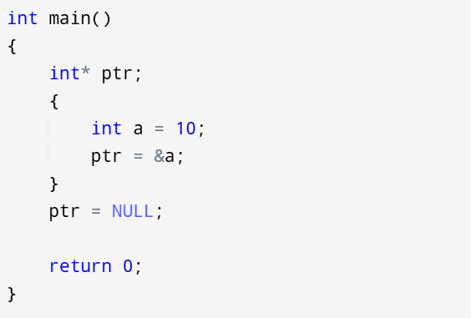

Wild pointers:
Uninitialized pointers are known as wild pointers because they point to some arbitrary or random memory location
It may leads to program crash if we try to access memory at arbitrary location.
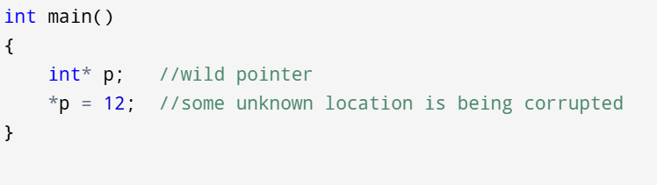

Solution: try to make wild pointer to point to a known location
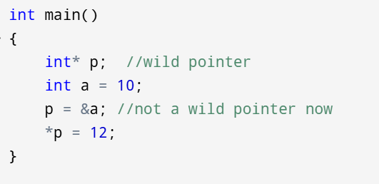

Void pointer: (generic pointer)
A void pointer can hold an address of any type and can be typecasted to any type.
1.void pointers cannot be dereferenced.
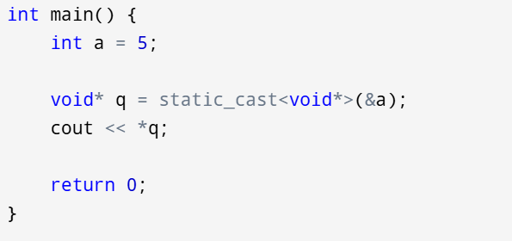
Compilation error

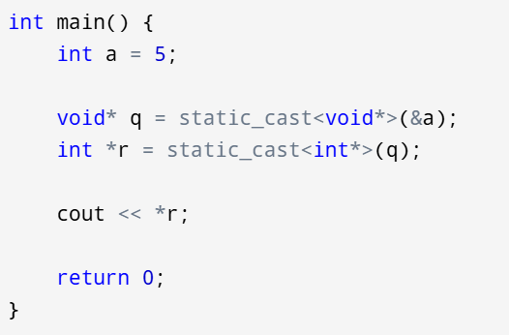
Output: 5

2. void pointers cannot hold const values.
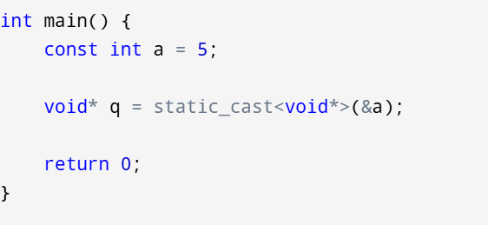

NULL pointer:
pointer is not pointing to anything. (The value of ptr is 0)
1.mainly used for error handling:
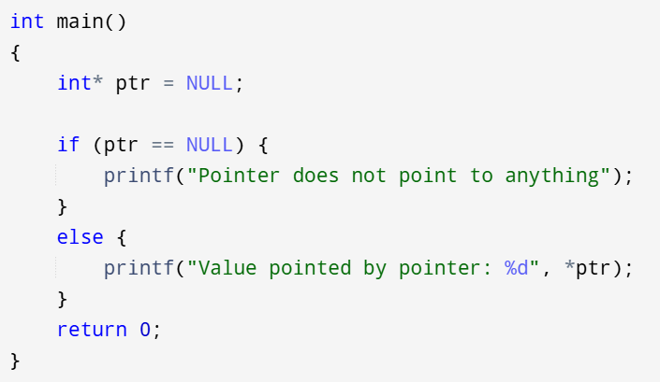

2.used by malloc() calloc() when there is no memory available in heap.
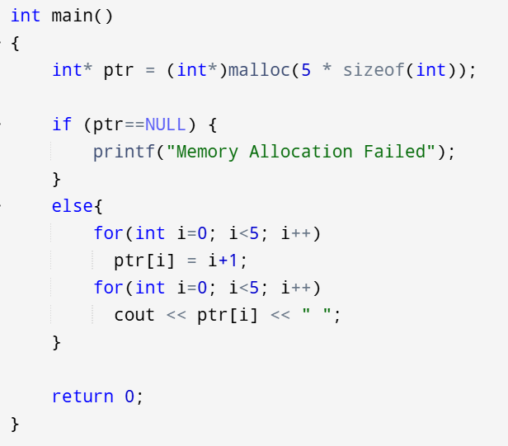

const :
During declaration itself we assign a value and this value cannot be changed over its lifetime.
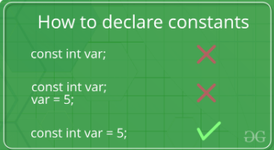

const int *ptr = &a;
pointer pointing to a const integer
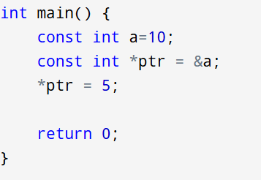
Compilation error

int* const ptr = &a;
constant pointer
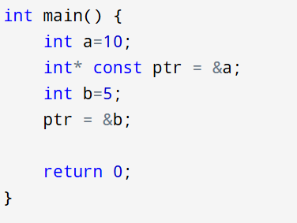
Compilation error

Structers and unions, Enumeration
Namespaces in C++
https://youtube.com/playlist?list=PLliXPok7ZonkJEe0cUbVZ3umyKbFA-Dd9&si=lENa7qTxeDNmtKdI
https://www.youtube.com/watch?v=bFtkHJy9kIU&t=3709s

